# Use cases

|  |  |  |  |
| --- | --- | --- | --- |
| Actor | Goals | Use Case (name) | Happy path |
| Customer        Travel Agent  System admin | To be able to make reservation  To be able to see available apartments  To be able to cancel reservation  To be able to pay upon booking  To be able to change booking      To be able to make reservation  To be able to see available apartments  To be able to cancel reservation  To be able to change booking  To be able to calculate commission  To be able to add apartments  To be able to remove apartments  To be able to change pricing  To be able to update information on apartments | Make reservation  Check availability  Cancel reservation  Make payment  Modify booking    Make reservation  Check availability  Cancel reservation  Modify booking  Calculate commission  Add new apartment  Remove apartment  Change pricing  Update apartment information | Customer visits site. Searches for a location and finds available apartment. Chooses dates and number of guest. Fills in personal details and credit card information. Customer receives booking confirmation. |

## Main success scenario

1. Customer visits France Vacances' main page
2. Customer navigates to booking page
3. Customer chooses date and gives number of guests
4. System provides available apartments, locations and price for specified dates in accordance with number of guests
5. Customer check details of potential apartments (Look at picture, read reviews ect.)
6. Customer selects apartment
7. Customer selects additional services
8. System updates total
9. Customer fills in personal contact details
10. System verifies email and phone number
11. System calculates total with taxes and in selected currency
12. Customer chooses credit card payment
13. Customer makes payment
14. System verifies payment
15. System updates availability calendar of apartments
16. Customer receives verification and detailed receipt
17. Customer leaves website

# Use case diagram

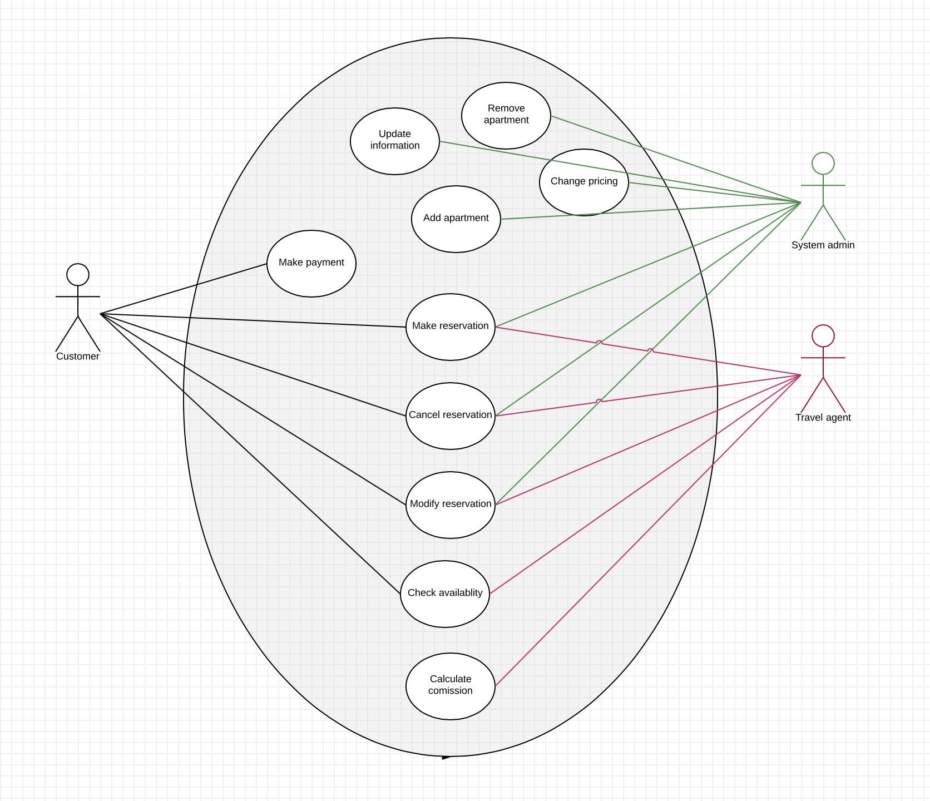

## Domain model

